
BUDGET TRACKER WITH EXPENSE CATEGORY
A MINI PROJECT REPORT
Submitted by
MOHAMMED NADHEER (727723EUCY032)
In partial fulfilment for the award of the degree
of
BACHELOR OF ENGINEERING
IN
COMPUTER SCIENCE AND ENGINEERING (CYBER SECURITY)
SRI KRISHNA COLLEGE OF ENGINEERING AND TECHNOLOGY
An Autonomous Institution | Approved by AICTE | Affiliated to Anna University | Accredited by NAAC with A++ Grade
Kuniamuthur, Coimbatore – 641008.
October 2025

SUSTAINABLE DEVELOPMENT GOALS
The Sustainable Development Goals are a collection of 17 global goals designed to blue print to achieve a better and more sustainable future for all. The SDGs, set in 2015 by the United Nations General Assembly and intended to be achieved by the year 2030. In 2015, 195 nations agreed as a blue print that they can change the world for the better. The project is based on one of the 17 goals.
Question | Answer
Which SDGs does the project directly address? | SDG 8 (Decent Work and Economic Growth) and SDG 12 (Responsible Consumption and Production)
What strategies or actions are being implemented to achieve these goals? | By providing a digital platform for expense tracking, budgeting, and financial goal setting
How is progress measured and reported in relation to the SDGs? | Through user adoption, improved savings, reduced overspending, and financial goal achievements
How were these goals identified as relevant to the project's objectives? | The project promotes financial literacy, accountability, and sustainable economic practices
Are there any partnerships or collaborations in place to enhance this impact? | Collaboration with financial institutions, fintech providers, and government bodies

BONAFIDE CERTIFICATE
Certified that this mini project report titled “Budget Tracker with Expense Category” is the bonafide work of MOHAMMED NADHEER (727723EUCY032) who carried out the mini project under my supervision.

SIGNATURE  DR. J REJINA PARVIN  HEAD OF THE DEPARTMENT  Professor  Department of CSE (Cyber Security)  Sri Krishna College of Engineering and Technology  Kuniyamuthur, Coimbatore–641008. | SIGNATURE  MR. ANANTRAJ I  SUPERVISOR  Asst Professor  Department of CSE (Cyber Security)  Sri Krishna College of Engineering and Technology  Kuniyamuthur, Coimbatore–641008.

Submitted for the Project viva-voce examination held on ____________________
INTERNAL EXAMINER EXTERNAL EXAMINER

ACKNOWLEDGEMENT
At this juncture, we take the opportunity to convey our sincere thanks and gratitude to the management of the college for providing all the facilities to us.
We wish to convey our gratitude to our college principal, DR. K PORKUMARAN, for forwarding us to do our project and offering adequate duration to complete our project.
We would like to express our grateful thanks to DR REJINA PARVIN, Head of the Department, Department of CSE (Cyber Security), for her encouragement and valuable guidance to this project.
We extend our gratitude to our beloved guide MR. ANANTRAJ I, Assistant Professor, Department of CSE (Cyber Security), for his constant support and immense help at all stages of the project.

ABSTRACT
With the increasing importance of digital financial management, individuals and organizations face challenges in tracking expenses, creating budgets, and achieving financial goals effectively. Traditional manual methods often lead to errors, lack of visibility, overspending, and poor financial planning.
To address these challenges, this project proposes the development of a Budget Expense Tracker System, a web-based solution that streamlines expense reporting, budget allocation, financial goal tracking, and analytics.
The system enables users to record expenses, categorize spending, set budgets, and monitor progress in real time, ensuring transparency and better control over finances. Administrators, finance managers, and analysts are equipped with role-based dashboards, advanced search and filtering, approval workflows, and comprehensive reporting tools to manage and analyse financial data.
Key features include user authentication, role-based access control, expense categorization, automated budget alerts, financial goal tracking, notifications, and performance analytics dashboards.
By providing a centralized and secure financial management platform, the Budget Expense Tracker enhances accountability, reduces overspending, supports informed decision-making, and improves overall financial well-being. This solution ensures organized financial operations and sustainable practices, leading to greater efficiency, transparency, and economic empowerment for users.

TABLE OF CONTENTS
ACKNOWLEDGEMENT iii
ABSTRACT iv
LIST OF TABLES vii
LIST OF FIGURES viii
LIST OF ABBREVIATIONS ix
1 INTRODUCTION 1
1.1 Overview 1
1.2 Components of System 2
1.3 Advanced Technologies 3
1.4 Global Perspectives 4
2 SYSTEM ANALYSIS 5
2.1 Existing System 5
2.1.1 Drawbacks 6
2.2 Problem Definition 7
2.3 Proposed System 8
2.3.1 Advantages 8
3 SYSTEM REQUIREMENTS 9
3.1 Hardware Requirements 9
3.2 Software Requirements 9
3.3 Software Description 9
3.3.1 Frontend 10
3.3.2 Backend 12
4 SYSTEM DESIGN 14
4.1 Module Description 14
4.1.1 User Management 14
4.1.2 Expense Management 15
4.1.3 Budget Management 16
4.1.4 Goal Management 17
4.1.5 Reports & Analytics 17
4.1.6 Admin Dashboard 18
4.2 Use Case Diagram 20
4.3 Sequence Diagram 21
4.4 Class Diagram 22
5 TESTING 23
5.1 Unit Testing 23
5.2 Integration Testing 23
5.3 Security and Authentication 23
5.4 Test Cases 25
5.4.1 Test Case I 26
5.4.2 Test Case II 26
6 CONCLUSION AND FUTURE WORK 27
6.1 Conclusion 27
6.2 Future Work 27
7 APPENDICES 28
Appendix I – Source Code 28
Appendix II – Screenshots 29
REFERENCES 34

LIST OF TABLES
Table No. | Title | Page No.
4.1.1 | User Management | 14
4.1.2 | Expense Management | 15
4.1.3 | Category Management | 16
4.1.4 | Budget Management | 17
4.1.5 | Goal Management | 18
4.1.6 | Notification & Audit Log Management | 19
4.1.7 | Reports & Analytics Management | 20

LIST OF FIGURES
Figure No. | Title | Page No.
3.1 | VS Code Logo | 9
4.1 | Use Case Diagram | 20
4.2 | Sequence Diagram | 21
4.3 | Class Diagram | 22
5.1 | Storing the token in local storage | 23
5.2 | Authenticating the user using bearer token | 24
5.3 | Test case I | 26
5.4 | Test case II | 26
A.2.1 | Home Page | 29
A.2.2 | Login Page | 29
A.2.3 | Registration Page | 30
A.2.4 | User Dashboard | 30
A.2.5 | Budget Management | 31
A.2.6 | Admin Dashboard | 31
A.2.7 | Managing Users | 32
A.2.8 | Reports and Analytics | 32

LIST OF ABBREVIATIONS
S. No | Abbreviation | Expansion
1 | ADL | Activities of Daily Living
2 | RAM | Random Access Memory
3 | GB | Giga Bytes
4 | VS | Visual Studio
5 | OS | Operating System
6 | HTTP | Hyper Text Transfer Protocol
7 | JPA | Java Persistence API
8 | API | Application Programming Interface
9 | JDBC | Java Database Connectivity
10 | SQL | Sequential Query Language
11 | UI | User Interface
12 | DOM | Document Object Model
13 | JSX | Java Script XML
14 | JWT | JSON Web Token
15 | UML | Unified Modelling Language
16 | DFD | Data Flow Diagram
17 | FAQ | Frequently Asked Questions

CHAPTER 1

INTRODUCTION

1.1 OVERVIEW
The growing reliance on digital financial services has created a strong need for efficient and reliable solutions to manage personal and business expenses. Traditional methods of tracking finances—such as manual records, spreadsheets, or fragmented tools—often lack accuracy, scalability, and transparency. These limitations make it difficult for individuals and organizations to ensure proper budgeting, monitor spending, and achieve financial goals effectively.
The Budget Expense Tracker System aims to address these challenges by offering a centralized, web-based platform that streamlines the process of recording expenses, managing budgets, and tracking financial goals. The system enables users to log their financial transactions, categorize spending, set budgets, and monitor progress in real time, while administrators and finance managers can oversee financial data, enforce policies, and generate analytical reports.
This platform provides structured workflows for expense categorization, budget allocation, goal tracking, and role-based access, ensuring accurate financial management and transparency. Users benefit from timely alerts, detailed insights, and better control over their finances, while administrators gain tools to monitor overall financial performance, allocate resources effectively, and ensure compliance with financial standards.
Key features of the system include expense and budget management, secure authentication, role-based dashboards, automated alerts, notifications, analytics, and reporting tools. By integrating these features, the Budget Expense Tracker ensures streamlined financial operations, accurate record-keeping, and improved decision-making.
Ultimately, the system reduces overspending, prevents financial mismanagement, and improves overall economic stability by providing an efficient, transparent, and reliable financial management process.

1.2 COMPONENTS OF SYSTEM

System Landing Page
The landing page acts as the entry point for users. It provides an overview of the application, access to login/registration, and navigation to core features like expense tracking, budget planning, and goal management.

User Dashboard
The dashboard serves as the central hub for standard and premium users. Users can record expenses, set budgets, track financial goals, and view analytics and reports in real time.

Finance Manager / Analyst Dashboard
Finance managers and budget analysts are provided with dedicated dashboards to oversee expenses, manage budgets, approve financial requests, and analyse spending patterns to support decision-making.

Expense Management
This component handles the complete lifecycle of expenses—from creation to categorization. It supports transaction entry, editing, recurring expenses, CSV/bank imports, receipt uploads, and real-time expense tracking.

Budget Management
The budget module allows users to create, allocate, and monitor budgets. It supports different budget types (monthly, yearly, category-specific), alerts for overspending, and approval workflows for shared/business budgets.

Goal Management
Users can set and track financial goals such as savings, debt repayment, or investment targets. Progress is monitored through milestones, visual indicators, and automated notifications.

Admin Panel
Administrators can manage users, configure categories, oversee budgets and expenses, monitor system health, review audit logs, and ensure compliance with financial policies and standards.

Notification & Communication Module
This module provides automated alerts and updates for budget limits, goal milestones, and financial events. Notifications are delivered via email, in-app messages, or push alerts, ensuring users stay informed.

Reporting and Analytics
The system includes advanced dashboards to generate financial reports, track spending trends, analyse budget vs actual performance, and provide insights into financial health for both individuals and organizations.

Security and Access Control
Role-based access control ensures that users, analysts, managers, and administrators can only access authorized functionalities. The system also supports secure authentication (JWT), encrypted financial data handling, and audit trails.

1.3 ADVANCED TECHNOLOGIES

AI-Powered Expense Categorization
Artificial Intelligence is used to automatically classify expenses based on transaction details, keywords, and spending patterns, ensuring greater accuracy and reduced manual effort.

Automated Budget Alerts
The system provides intelligent alerts when spending approaches or exceeds budget limits, helping users maintain financial discipline and achieve savings goals.

Financial Chatbot Assistance
An integrated chatbot assists users by answering queries about expenses, budgets, or goals, and provides quick tips for financial planning and responsible consumption.

Real-Time Notifications
Users receive instant notifications about new expense entries, goal progress, budget thresholds, and account activities via email, SMS, or in-app alerts.

Multi-Device Support
The system is built with a responsive, mobile-friendly interface, enabling users, analysts, and managers to access financial dashboards seamlessly across desktops, tablets, and smartphones.

Analytics & Reporting Dashboard
Built-in analytics provide insights into spending trends, budget vs actual performance, savings progress, and financial health scores, enabling data-driven financial decision-making.

Secure Authentication & Role-Based Access
The system implements secure login mechanisms, JWT-based authentication, and role-based access control (RBAC) to ensure financial data is protected and accessible only to authorized users.

1.4 GLOBAL PERSPECTIVES
Global perspectives on financial management systems are shaped by digital transformation, growing financial awareness, the need for transparency, and the global push toward sustainable economic practices.
- Rising Demand for Digital Financial Tools — With globalization and the growth of digital economies, individuals and organizations worldwide increasingly require efficient platforms to manage expenses, track budgets, and achieve financial goals with accuracy and reliability.
- Shift Toward Centralized Financial Management Systems — Globally, users are moving away from fragmented methods like spreadsheets or manual records toward centralized platforms that provide transparency, accountability, and integrated financial workflows.
- Integration of Advanced Technologies — Artificial intelligence, cloud infrastructure, mobile applications, and predictive analytics are being embedded into financial platforms to automate categorization, deliver insights, and reduce human error.
- Focus on Financial Literacy & User Experience — Modern financial platforms emphasize intuitive dashboards, real-time alerts, multi-currency support, and role-based access, ensuring that users gain control, awareness, and confidence in managing their finances.
- End-to-End Ecosystem Integration — Globally, expense management systems are evolving to integrate with banking APIs, payment systems, CRM tools, and enterprise resource planning (ERP). This enables seamless financial tracking, compliance monitoring, and data-driven decision-making within a unified ecosystem.

CHAPTER 2

SYSTEM ANALYSIS

2.1 EXISTING SYSTEM
The current approach to managing personal and business expenses often relies on manual methods such as notebooks, spreadsheets, or standalone applications. While these methods provide basic tracking, they lack automation, transparency, and real-time monitoring. Many existing financial tracking tools provide only limited features such as simple expense logging, without budget allocation, goal tracking, or advanced analytics to support informed financial decisions.
For administrators and financial managers, traditional systems often offer only basic account management. Tools for monitoring financial performance, approving budgets, auditing expenses, or generating detailed reports are frequently missing. Security in existing solutions is often weak. Many do not implement role-based access control, strong authentication, or encrypted data storage, leaving sensitive financial information vulnerable.
Overall, existing expense tracking systems provide only partial solutions, falling short of delivering a comprehensive, efficient, and secure financial management platform that can scale to meet modern needs.

2.1.1 DRAWBACKS

Quality of Service
- Inaccurate tracking: Manual or basic systems often lead to missed entries, duplicate records, and poor financial visibility.
- User experience variability: Many tools lack intuitive dashboards or mobile-friendly designs, creating usability challenges.

Limited Functionality
- Feature gaps: Common features like budget allocation, goal tracking, automated alerts, receipt scanning, and advanced analytics are often missing.
- Integration gaps: Many systems fail to integrate with banking APIs, payment systems, or enterprise tools, limiting seamless financial management.

Security and Privacy
- Data breach risks: Weak authentication and lack of encryption leave sensitive financial data exposed.
- Privacy concerns: Lack of transparency in how financial data is stored or shared reduces user trust.

Usability Challenges
- Learning curve: Some financial tools are either too basic to be effective or too complex for non-technical users, hindering adoption.
- Technical issues: Downtime, slow response, or lack of real-time synchronization negatively affect financial accuracy and decision-making.

Cost Considerations
- Premium costs: Advanced features like financial analytics, multi-user support, or cloud backup are often restricted to expensive premium plans.
- Hidden costs: Some platforms charge extra for integrations, storage, or additional reporting tools, making them less accessible to small businesses and individuals.

2.2 PROBLEM DEFINITION
- Quality of Service Issues: Existing systems fail to provide accurate tracking, personalized insights, or real-time monitoring, leading to poor financial visibility and user dissatisfaction.
- Limited Functionality: Many platforms lack features such as automated budget alerts, financial goal tracking, receipt scanning, advanced analytics, and integration with external banking or payment systems.
- Lack of Management Control: Manual and basic systems do not allow administrators or finance managers to track financial performance, enforce policies, allocate budgets effectively, or generate meaningful reports.
- Security Concerns: Weak authentication, insufficient encryption, and lack of role-based access expose sensitive financial data to risks and reduce user trust.

2.3 PROPOSED SYSTEM
- User-Friendly Interface: Provides an intuitive dashboard where users can record expenses, set budgets, and track financial goals easily.
- Efficient Expense Management: Allows users to categorize expenses, manage recurring transactions, upload receipts, and monitor spending in real time.
- Role-Based Access Control: Ensures different access levels for users, finance managers, analysts, and administrators for secure and organized financial workflows.
- Automated Notifications & Tracking: Sends real-time alerts about budget thresholds, goal progress, and important financial events.
- Reporting & Analytics: Provides users and administrators with dashboards to analyse spending trends, compare budget vs actual, and generate financial reports.
- Secure Authentication: Implements strong login mechanisms, JWT-based authentication, and encrypted data storage to safeguard sensitive financial information.
- Communication & Alerts Module: Enables users to receive updates, reminders, and notifications directly through the system for better financial planning and awareness.

2.3.1 ADVANTAGES
- Streamlined and organized expense and budget management
- Comprehensive platform with end-to-end financial tracking and goal management features
- Improved decision-making and financial discipline through real-time insights and alerts
- Enhanced transparency and trust with accurate reports and analytics
- Strong security with role-based access control, JWT authentication, and encryption
- Scalable, cost-effective, and easy-to-use solution for individuals and organizations

CHAPTER 3

SYSTEM REQUIREMENTS
The hardware and software requirements and also the platform description of the system are explained under sections 3.1, 3.2 and 3.3 respectively.

3.1 HARDWARE REQUIREMENTS
S.No | Component | Specification
1 | Processor Type | Ryzen i5
2 | RAM | 8 GB RAM
3 | Hard Disk | 512 GB

3.2 SOFTWARE REQUIREMENTS
S.No | Component | Specification
a | Operating System | Windows 11
b | Front End, Back End | Visual Studio Code
c | Coding Language | ReactJs, Java

3.3 SOFTWARE DESCRIPTION
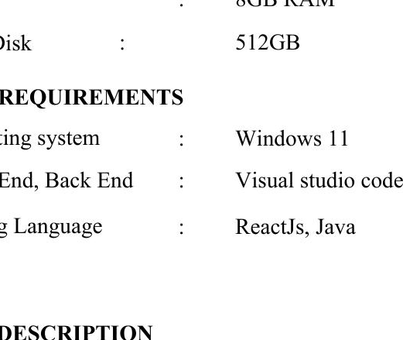
Fig. 3.1. VS Code Logo
Visual Studio Code, also commonly referred to as VS Code, is a source-code editor made by Microsoft; it can be used to work with Windows, Linux and macOS. Features include support for debugging, syntax highlighting, intelligent code completion, snippets, and embedded Git. Users can change the theme, keyboard shortcuts, preferences, and install extensions that add functionality.

3.3.1 FRONTEND — ReactJs
ReactJS is a popular JavaScript library for building user interfaces, particularly for web applications. React follows a component-based architecture, where UIs are broken down into reusable components. Each component encapsulates its own logic and UI, making it easier to manage and maintain complex user interfaces.
React uses a virtual DOM (Document Object Model) to improve performance. Instead of directly manipulating the DOM, React creates a virtual representation of the DOM in memory and updates it efficiently. When changes occur, React compares the virtual DOM with the actual DOM and only updates the necessary parts, reducing the number of DOM manipulations and improving performance.
React uses JSX, a syntax extension that allows developers to write HTML-like code within JavaScript. JSX makes it easier to write and understand React components, as it closely resembles the final UI structure. React follows a unidirectional data flow, also known as one-way data binding. Data flows from parent components to child components via props, and child components can communicate with parent components via callbacks. This helps maintain a clear and predictable data flow in the application.

Features of ReactJs
- Declarative: React makes it easy to create interactive UIs by using a declarative programming approach. Developers can describe how the UI should look based on the application state.
- Component-Based: React uses a component-based architecture, where UIs are composed of reusable and self-contained components. This makes it easier to manage and maintain complex UIs, as each component can be developed, tested, and updated independently.
- Virtual DOM: React uses a virtual DOM to improve performance. Instead of updating the entire DOM when the state changes, React compares the virtual DOM with the actual DOM and only updates the parts that have changed.
- JSX: JSX is a syntax extension for JavaScript that allows developers to write HTML-like code within their JavaScript code. This makes it easier to create and manage UI components, as JSX code can be more readable.
- Unidirectional Data Flow: React follows a unidirectional data flow, from parent components to child components. This helps to maintain the consistency of the application state and understand the data flow in the application.
- React Native: React Native is a framework for building native mobile applications using React. It allows developers to use the same codebase to build both iOS and Android applications, saving time and effort in development.
- Community and Ecosystem: React has a large and active community of developers, which has led to the development of a rich ecosystem of libraries, tools, and resources that can be used to enhance and extend React applications.

3.3.2 BACKEND — Java
Java is a versatile, object-oriented programming language renowned for its platform independence, security, and portability. Java is a high-level, general-purpose programming language that is widely used for developing a variety of applications. Java is object-oriented, emphasizing the use of classes and objects for organizing code and data.
It boasts a comprehensive standard library with built-in classes and APIs for various tasks, from data manipulation to networking. Java enforces strong type checking, enhancing code reliability and reducing runtime errors. The language includes automatic memory management through garbage collection, simplifying memory allocation and deallocation.
The extensions used to develop the backend part of the project are:
- Spring Boot Extension Pack by VMware: This extension pack provides a set of tools and features to enhance development experience with Spring Boot, including code snippets, syntax highlighting, and project templates.
- Extension Pack for Java by Microsoft: This extension pack includes essential tools for Java developers, such as debugging support, code navigation, and IntelliSense for Java files.
- Spring Boot Snippets by Developer Soapbox: This extension provides a collection of code snippets for commonly used Spring Boot annotations and configurations, helping write code more efficiently.
Dependencies used to build the project are:
- Spring Web: This dependency provides the necessary components for building web applications with Spring, including controllers, request mappings, and HTTP message converters.
- Dev Tools: Spring Boot DevTools provides a set of tools to improve the development experience, including automatic application restarts, live reload, and enhanced debugging capabilities.
- Data JPA: Spring Data JPA provides support for easily working with JPA (Java Persistence API) repositories, simplifying the implementation of data access logic in the application.
- Postgres Driver: This dependency provides the JDBC driver for PostgreSQL, allowing the Spring Boot application to connect to a PostgreSQL database.
- Lombok: Lombok is a library that helps reduce boilerplate code in Java classes by automatically generating getters, setters, and other repetitive code based on annotations.
- Spring Security Web: This dependency provides support for securing the web application using Spring Security, including authentication and authorization mechanisms.

CHAPTER 4

SYSTEM DESIGN

4.1 MODULE DESCRIPTION
- User Management
- Expense Management
- Budget Management
- Goal Management
- Reports & Analytics
- Admin Dashboard

4.1.1 USER MANAGEMENT
The user management module enables standard users, premium users, finance managers, analysts, and administrators to create and manage their accounts. It ensures secure authentication, role-based access control, and accurate maintenance of user details. Users can register and log in to record expenses, set budgets, and track goals, while finance managers and analysts can monitor financial activities and reports. Administrators can oversee the entire system, manage user access, and ensure compliance with security and data protection standards.
Table 4.1 User Management
Field | Description
UserID | Unique identifier for each user
Name | Full name of the user
Email | User's email address, used for login and communication
Password | Encrypted (hashed) password for secure login
Role | Defines whether the user is a User or Admin

4.1.2 EXPENSE MANAGEMENT
The expense management module allows users to record, categorize, and monitor their daily, weekly, or monthly expenses. It ensures accurate tracking, secure storage, and easy retrieval of expense data. Users can add, update, or delete expense entries, attach receipts, and view expense summaries for better financial planning.
Table 4.2 Expense Management
Field | Description
Expense ID | Unique identifier for each expense entry
User ID | Identifier of the user who recorded the expense
Category | Category of the expense (e.g., Food, Travel, Utilities)
Amount | Monetary value of the expense
Date | Date when the expense occurred
Description | Optional notes or details about the expense

4.1.3 BUDGET MANAGEMENT
The budget management module allows users to create, monitor, and manage budgets. It ensures that users can plan their spending effectively, set limits for each category, and receive alerts when approaching or exceeding the budget.
Table 4.3 Budget Management
Field | Description
Budget ID | Unique identifier for each budget
User ID | Identifier of the user who created the budget
Category | Category for which the budget is set
Amount | Allocated amount for the budget
Start Date | Start date of the budget period
End Date | End date of the budget period
Status | Current status of the budget (Active, Completed, Exceeded)

4.1.4 GOAL MANAGEMENT
The goal management module enables users to set financial goals, track progress, and achieve targets over time. It supports short-term and long-term goals with reminders and progress updates.
Table 4.4 Goal Management
Field | Description
Goal ID | Unique identifier for each goal
User ID | Identifier of the user who created the goal
Goal Name | Name or title of the financial goal
Target Amount | Amount the user aims to achieve
Current Amount | Current progress toward the goal
Start Date | Date when the goal is created
End Date | Target completion date for the goal
Status | Current status of the goal (In Progress, Achieved, Pending)

4.1.5 REPORTS & ANALYTICS
The reports & analytics module provides users and managers with visual and tabular insights into expenses, budgets, and goals. It helps analyze spending patterns, identify trends, and make informed financial decisions.
Table 4.5 Reports & Analytics
Field | Description
Report ID | Unique identifier for each report
User ID | Identifier of the user or manager requesting the report
Report Type | Type of report (Expense Summary, Budget Report, Goal Progress)
Generated Date | Date and time when the report was generated
Data Range | Time period covered by the report
Format | Format of the report (PDF, Excel, Dashboard view)

4.1.6 ADMIN DASHBOARD
The admin dashboard module allows administrators to oversee the entire system, manage users, monitor financial activities, and ensure compliance with security and data protection standards.
Table 4.6 Admin Dashboard
Field | Description
Admin ID | Unique identifier for each admin
User Management | Access to view, create, update, or deactivate user accounts
Reports Access | Access to all user reports, analytics, and summaries
System Logs | Records of system activities, user actions, and security events
Settings | Configuration options for roles, permissions, and system parameters

4.2 USE CASE DIAGRAM
A use case diagram is a visual representation in UML (Unified Modelling Language) that illustrates the interactions between actors and a system or software application.
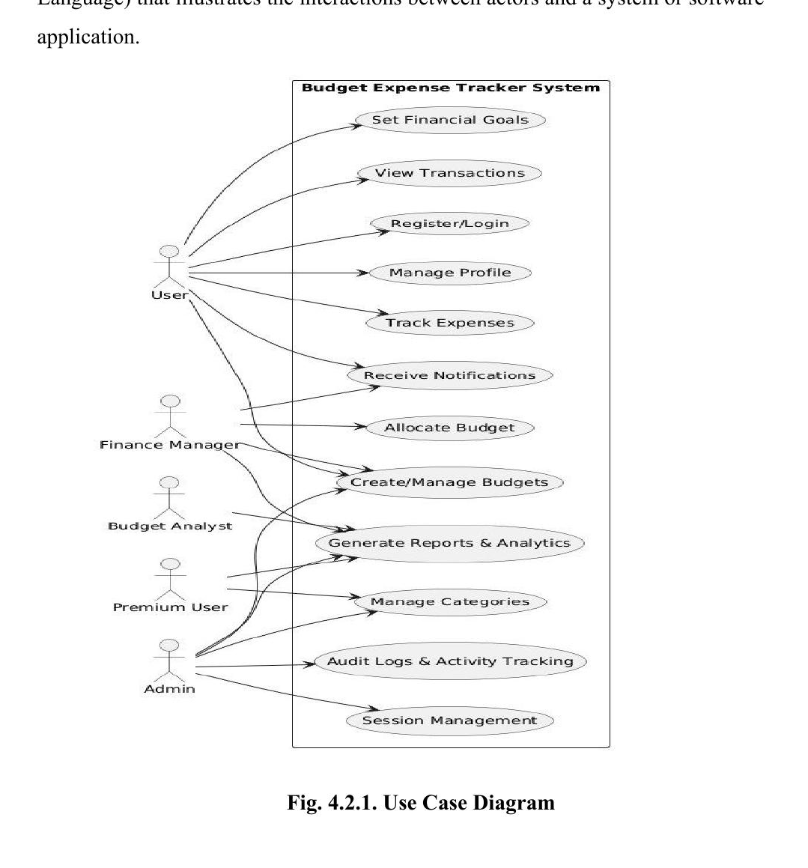
Fig. 4.2.1. Use Case Diagram

4.3 SEQUENCE DIAGRAM
A sequence diagram is a visual representation used in software engineering to illustrate the interactions and communication between different objects or components in a system over a specific period of time. It shows the chronological order of messages or method calls exchanged between these entities, helping to depict the dynamic behaviour of a system or a particular scenario. In essence, it provides a time-ordered view of how various parts of a system collaborate to achieve a particular task or functionality.
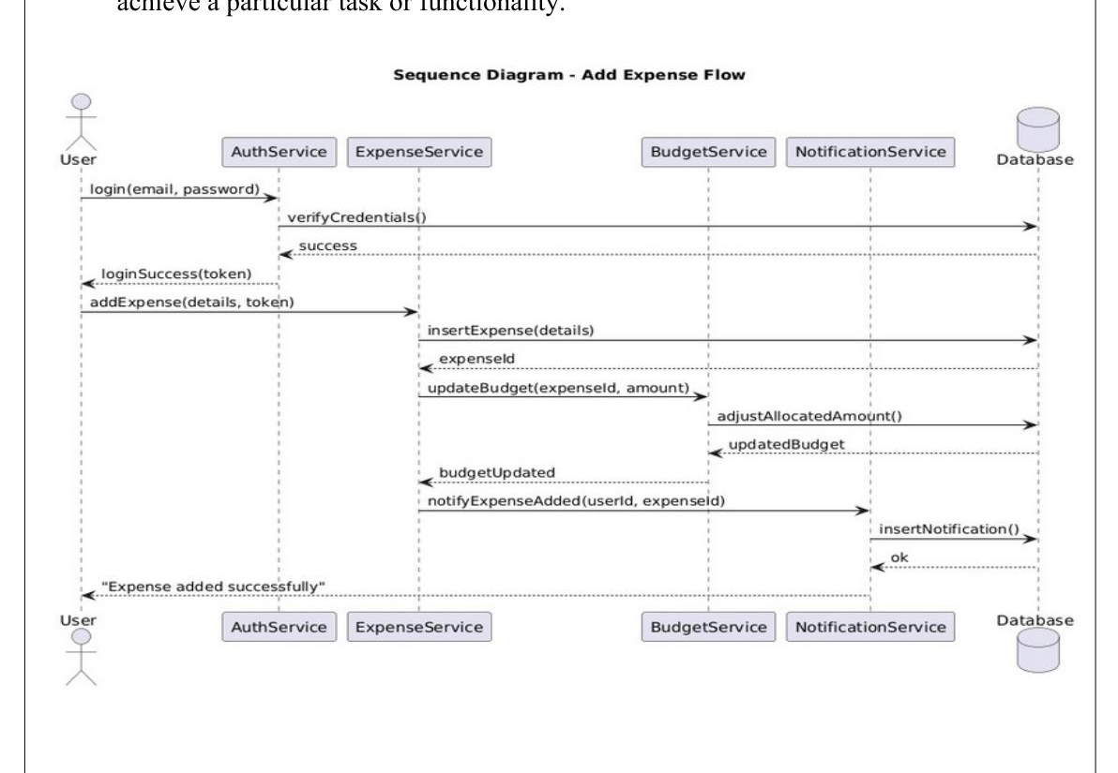
Fig. 4.2. Sequence Diagram

4.4 CLASS DIAGRAM
A Class Diagram is a structural diagram in Unified Modeling Language (UML) that describes the static structure of a system. It defines the system's classes, their attributes, operations (methods), and the relationships between them. Class diagrams are essential in object-oriented design because they provide a blueprint for how the system will be implemented in code.
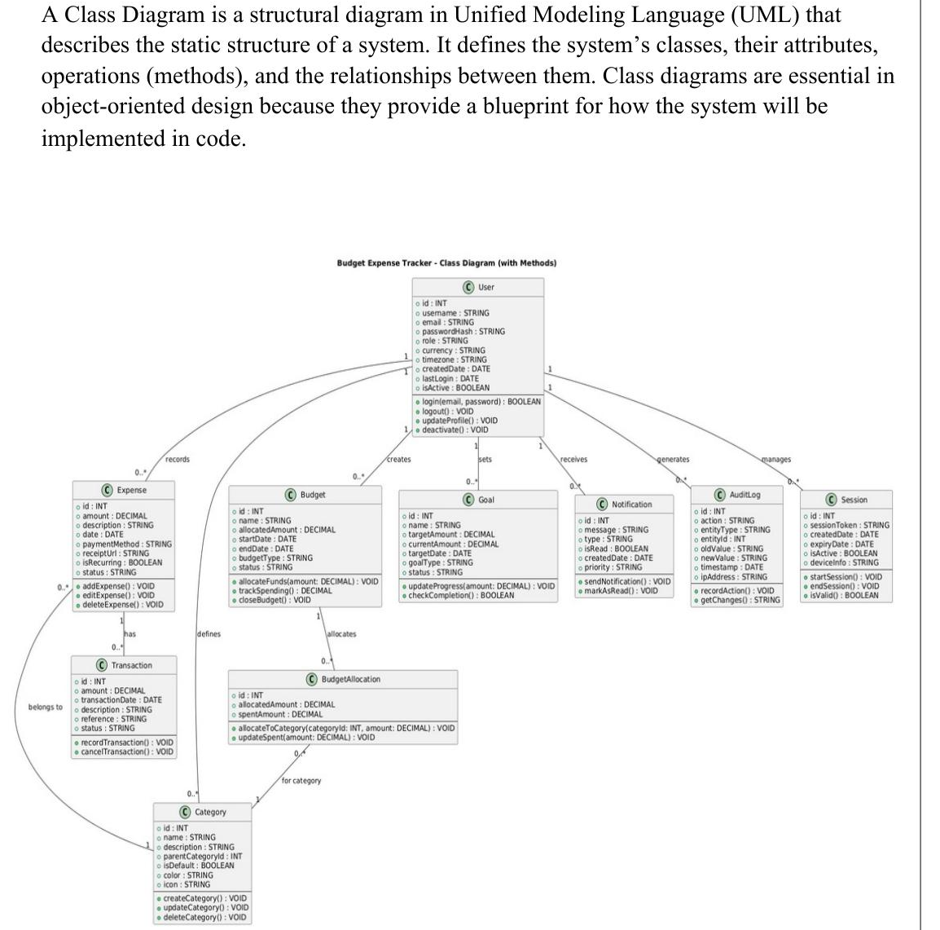
Fig. 4.3. Class Diagram

CHAPTER 5

TESTING

5.1 UNIT TESTING
Unit testing forms the foundational layer of the testing process for the project. It involves testing individual software components in isolation to identify and rectify issues early in the development cycle. In this context, unit testing entails examining Java classes and database queries individually. Unit testing, often conducted concurrently with development, focuses on validating the smallest units of the software, ensuring that each component works correctly and integrates seamlessly into the larger system.

5.2 INTEGRATION TESTING
Integration testing focuses on ensuring seamless interactions and interfaces between different components of the system. The goal is to validate that API endpoints responsible for data exchange between the front-end and back-end work harmoniously together. This phase ensures accurate data flow and cooperation among components, ultimately validating the overall functionality of the system for efficient coordination and delivery of the application's services.

5.3 SECURITY AND AUTHENTICATION
Ensuring the security and authentication of user data is of utmost importance. To achieve this, JSON Web Tokens (JWTs) are used for user authentication. During user registration, the platform securely stores encrypted credentials in its database. Upon successful registration, a unique JWT is generated and issued to the user. This JWT serves as a digital authentication token, allowing the user secure access to the platform's features.
The JWT, containing essential user information, is securely signed using a secret key known only to the server. This ensures the authenticity and integrity of the token. Whenever a user interacts with the platform, they include this JWT in their requests. The backend then validates the JWT to grant access to the requested resources. To enhance security, JWTs have a finite expiration time. Upon expiration, users must re-authenticate by logging in again to obtain a new JWT.
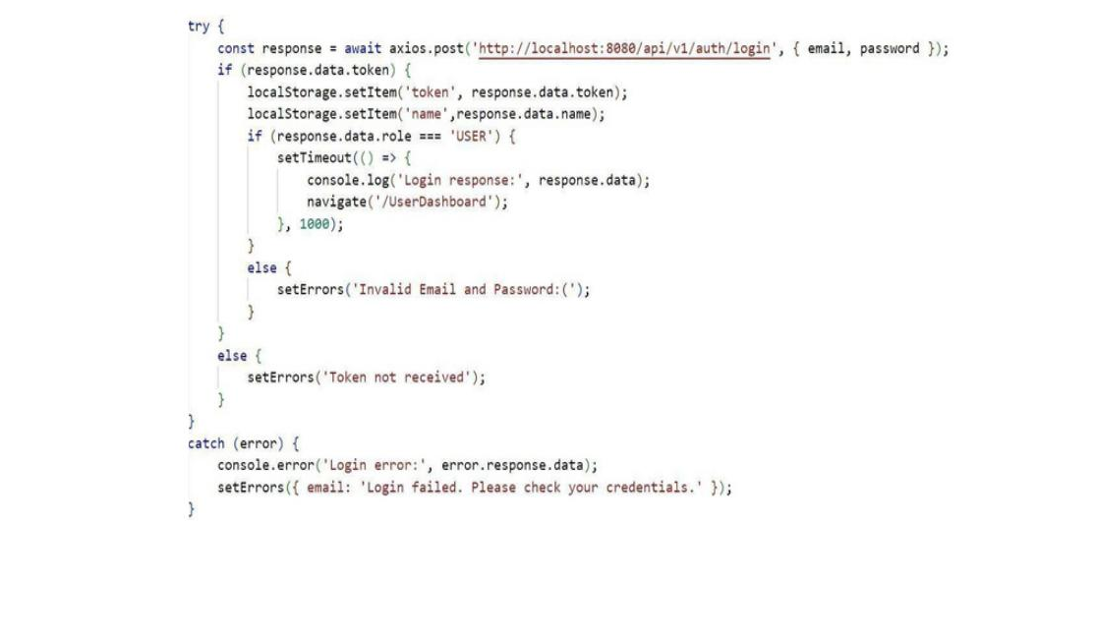
Fig. 5.1. Storing the Token in Local Storage
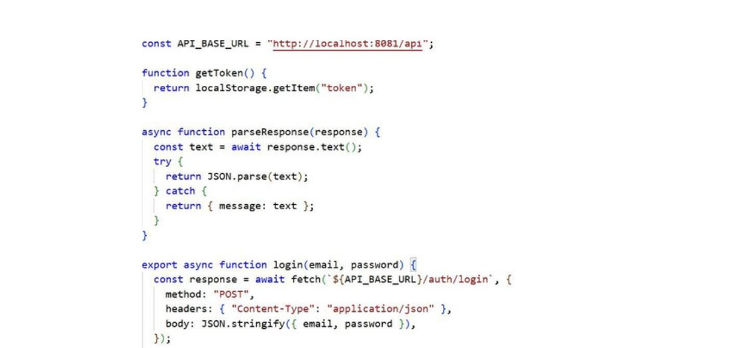
Fig. 5.2. Authenticating the User using Bearer Token

5.4 TEST CASES
Test cases are essential for evaluating the functionality of the application, including user registration and authentication, expense entry, budget management, and reporting. They help ensure that all features work as expected, identify potential issues, and provide a seamless user experience while maintaining overall system quality, security, and reliability.

5.4.1 TEST CASE I
Scenario: User logs in with incorrect credentials.
Expected Output: Login fails, and an error message is displayed stating "Invalid email or password".
Actual Output: Login attempt fails, and the user is prompted to re-enter correct credentials.
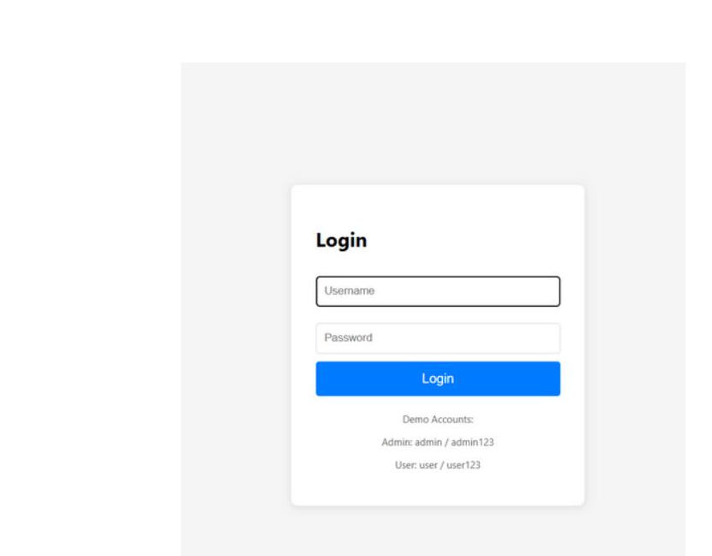
Fig. 5.4. Test Case I

5.4.2 TEST CASE II
Scenario: User tries to add an expense without entering all required fields (e.g., Name or Amount).
Expected Output: The system displays an error message: "Please enter both name and amount." The expense is not added.
Actual Output: The system prevents the expense from being recorded and shows the same error message.
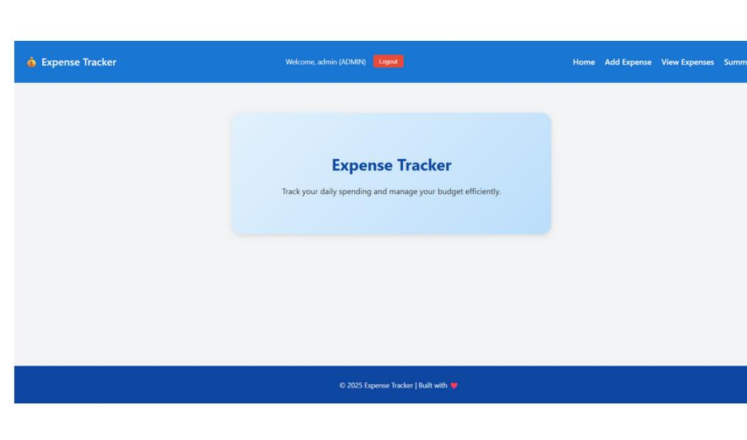
Fig. 5.4. Test Case II

CHAPTER 6

CONCLUSION AND FUTURE WORK

6.1 CONCLUSION
The Budget and Expense Management System provides a comprehensive platform for users to manage their personal finances effectively. By offering features such as recording expenses, categorizing them, setting budget limits, and tracking progress toward financial goals, the system enhances both planning and financial awareness. Its intuitive interface and seamless user experience allow users to maintain accurate financial records, monitor spending, and make informed decisions. Overall, the project successfully integrates expense tracking, budget management, goal monitoring, and analytics, making it a valuable tool for personal financial management and planning.

6.2 FUTURE WORK

1. Mobile Application Development
Developing a mobile version of the system would allow users to manage expenses, budgets, and goals on-the-go. Features could include push notifications for budget alerts, goal reminders, offline expense tracking, and integration with digital payment platforms for seamless transactions.

2. Enhanced Analytics and Insights
Incorporating advanced analytics would provide users with deeper insights into their spending patterns, budget utilization, and goal progress. Features such as trend analysis, category-wise spending breakdown, and predictive alerts could help users make smarter financial decisions.

3. Automated Reports and Notifications
Future enhancements could include automated monthly or weekly financial reports sent via email or app notifications, helping users stay updated on their financial health without manual effort.

4. Multi-User and Shared Budgets
Allowing shared budgets for families or teams would enable collaborative expense management, providing visibility and control over group spending and collective financial goals.

CHAPTER 7

APPENDICES

APPENDIX I — SOURCE CODE

HomePage.jsx
import React, { useEffect, useState } from "react"; import Navbar from "../components/Navbar"; import Footer from "../components/Footer"; import "../index.css"; export default function Home() { const [cards, setCards] = useState([ { title: "Expense Tracking", description: "Categorize and track your daily spending effortlessly.", color: "bg-gradient-to-r from-yellow-400 via-orange-400 to-red-500", }, { title: "Budgeting", description: "Create smart budgets and never overspend again.", color: "bg-gradient-to-r from-green-400 via-teal-400 to-blue-500", }, { title: "Reports", description: "Visualize your financial health with clear reports.", color: "bg-gradient-to-r from-purple-400 via-pink-400 to-red-400", }, ]); const [animate, setAnimate] = useState(false); useEffect(() => { const timer = setTimeout(() => setAnimate(true), 200); return () => clearTimeout(timer); }, []); return ( <div className="flex flex-col min-h-screen bg-gray-50"> <Navbar /> <main className="flex-grow"> <div className="max-w-6xl mx-auto px-6 py-24 text-center"> <h1 className="text-5xl md:text-6xl font-extrabold mb-6 text-gray-900 drop-shadow-lg"> Take Control of Your Finances </h1> <p className="text-lg md:text-xl opacity-90 max-w-2xl mx-auto mb-12 text-gray-700"> Track your expenses, manage budgets, and gain insights into your spending habits — all in one beautiful, modern app. </p> <h2 className="text-3xl font-bold mb-6 text-gray-800">Why We Use This App</h2> <section className="grid grid-cols-1 md:grid-cols-3 gap-8"> {cards.map((card, index) => ( <div key={index} className={`p-8 rounded-3xl shadow-2xl text-white transform transition-all duration-700 ease-out ${animate ? "opacity-100 translate-y-0" : "opacity-0 translate-y-10"} ${card.color}`} style={{ transitionDelay: `${index * 200}ms` }} > <h3 className="text-2xl font-bold mb-4">{card.title}</h3> <p className="text-white/90">{card.description}</p> </div> ))} </section> </div> </main> <Footer /> </div> ); }

APPENDIX II — SCREENSHOTS
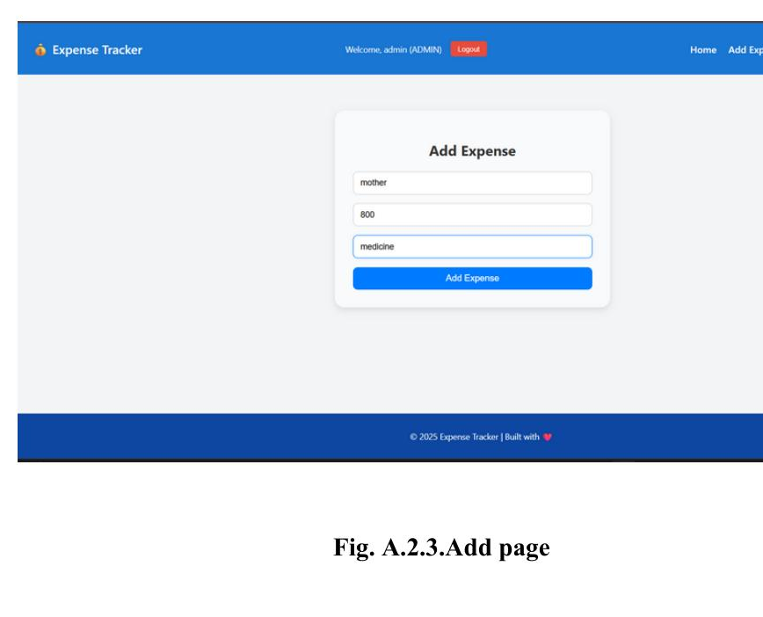
Fig. A.2.3. Add Expense Page
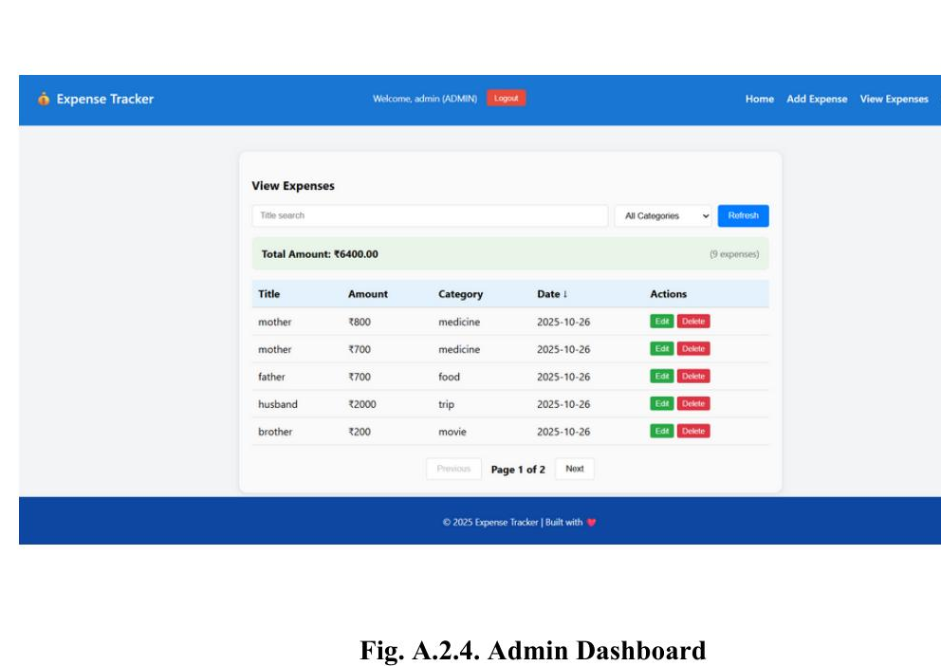
Fig. A.2.4. Admin Dashboard
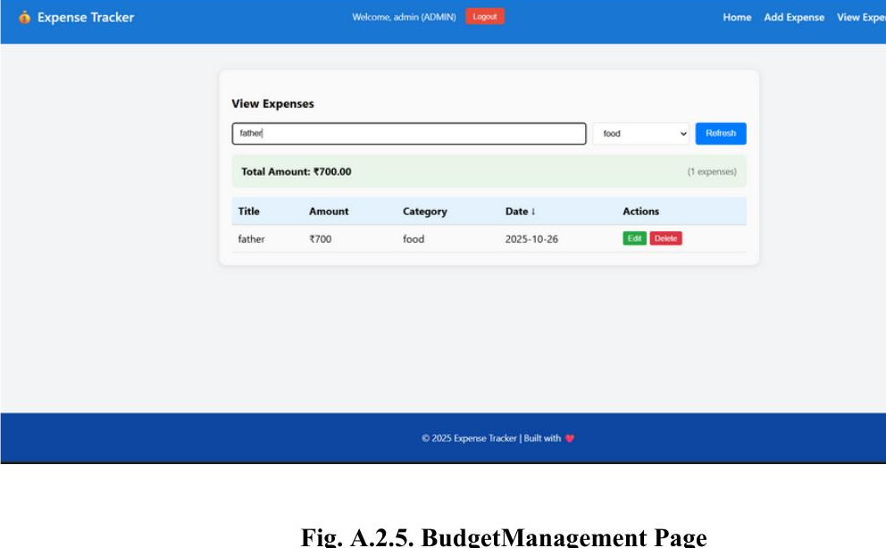
Fig. A.2.5. Budget Management Page
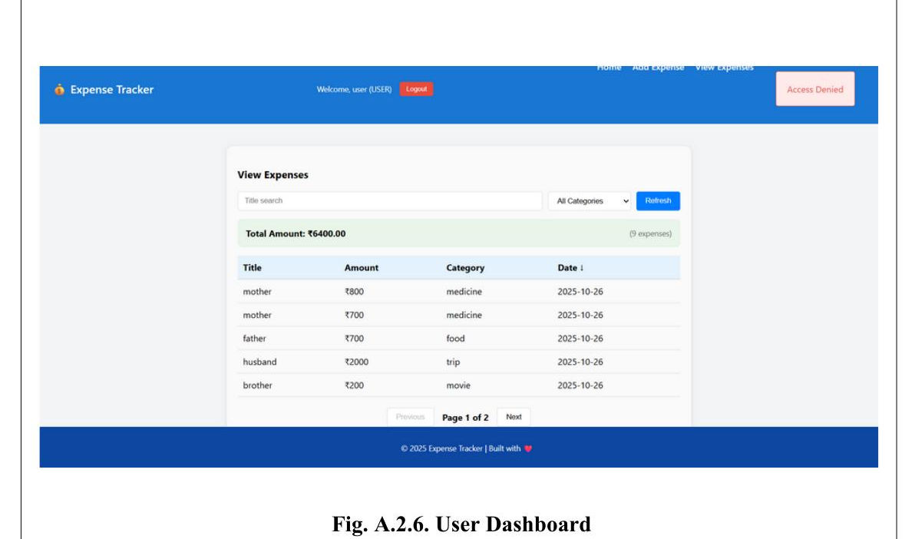
Fig. A.2.6. User Dashboard
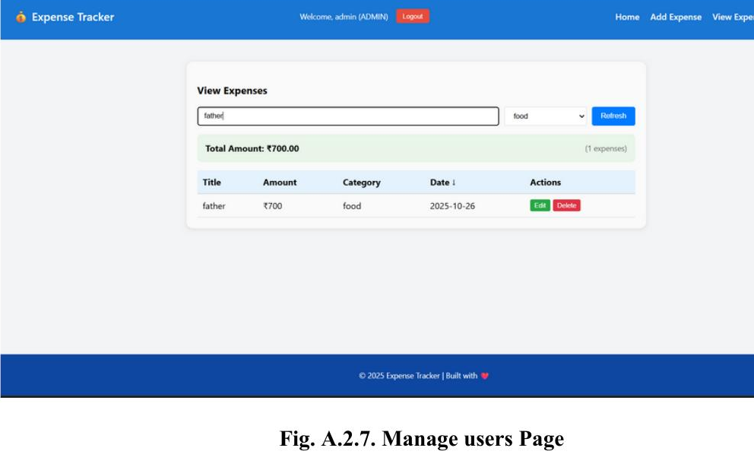
Fig. A.2.7. Managing Users Page
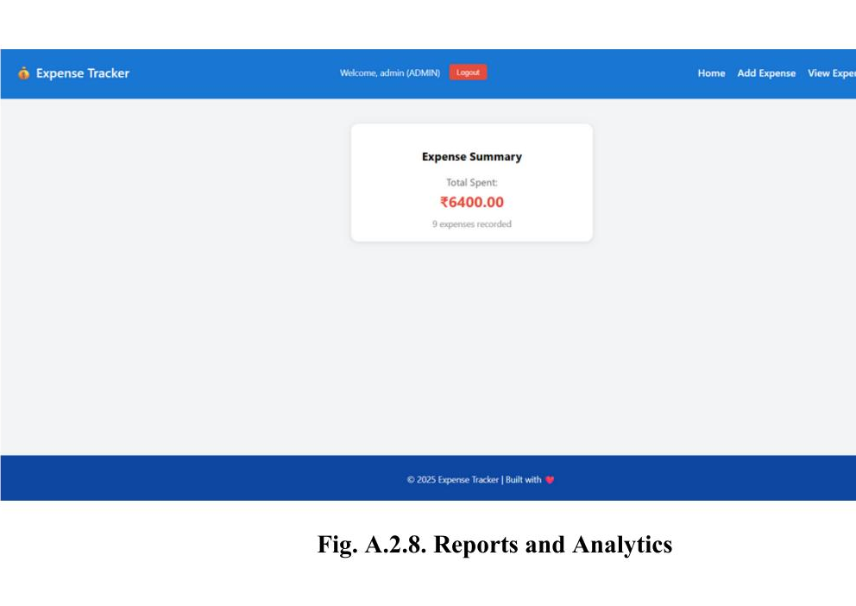
Fig. A.2.8. Reports and Analytics

REFERENCES

Web References
[1] PostgreSQL Official Documentation: https://www.postgresql.org/docs/
[2] React Official Documentation: https://react.dev/learn
[3] Spring Boot Official Documentation: https://spring.io/projects/spring-boot
[4] Spring Security Official Documentation: https://spring.io/projects/spring-security
[5] Swagger Official Documentation: https://swagger.io/tools/swagger-ui/
[6] Material UI Official Documentation: https://mui.com/material-ui/getting-started/
[7] JSON Web Token (JWT) Official Documentation: https://jwt.io/introduction/

Book References
[1] Robert C. Martin (2008), Clean Code: A Handbook of Agile Software Craftsmanship, Prentice Hall
[2] Martin Fowler (2002), Patterns of Enterprise Application Architecture, Addison-Wesley
[3] Eric Evans (2003), Domain-Driven Design: Tackling Complexity in the Heart of Software, Addison-Wesley
[4] Kyle Simpson (2015), You Don't Know JS (Book Series), O'Reilly Media
[5] Craig Walls (2016), Spring Boot in Action, Manning Publications
[6] Stoyan Stefanov (2013), React: Up and Running: Building Web Applications, O'Reilly Media
[7] Ethan Brown (2019), Web Development with Node and Express, O'Reilly Media
[8] Jennifer Thompson (2021), Vehicle Parking Management Systems: Design, Software, and Applications, Tech Urban Publish

